**HW1-A: Screenshot**

1. On March 28th Monday, the time table colored by red.

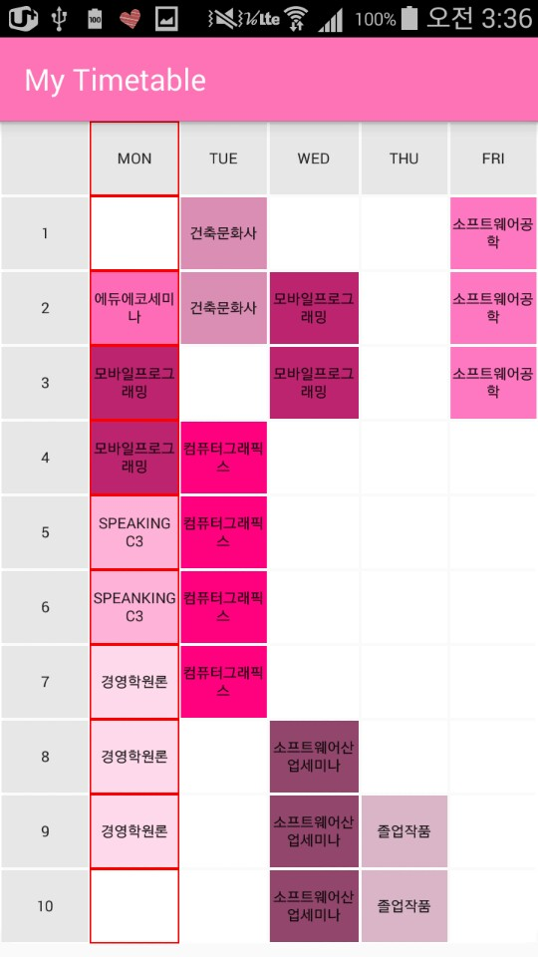

1. This same happened with screen turned in the other side.

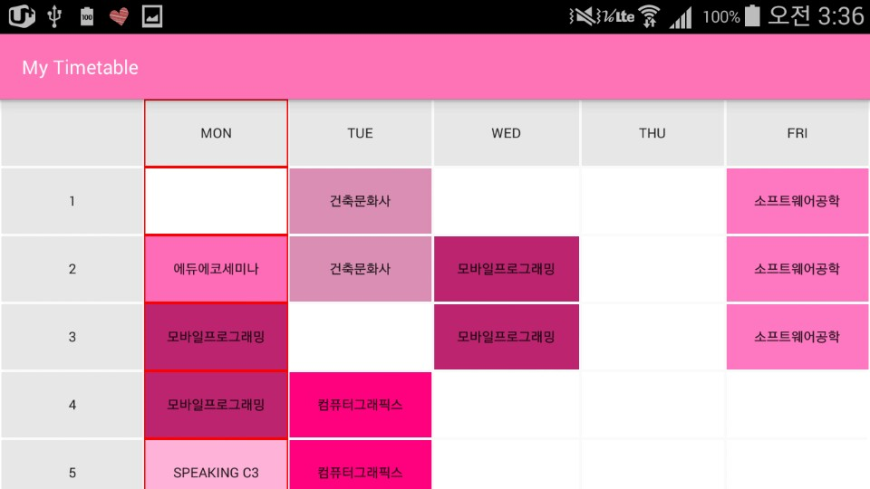

1. Also when the timetable bigger than screen size, it makes scroll to show all table.

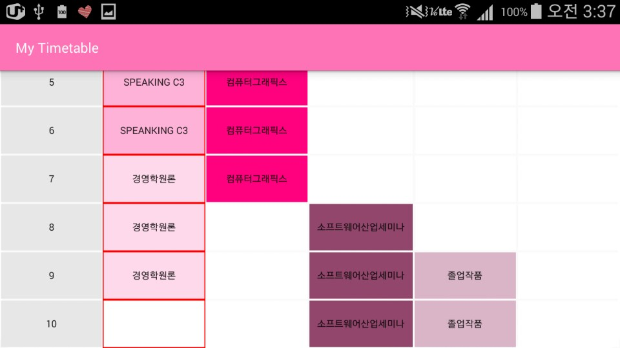

**HW1-A: Github**

<https://github.com/hansolkatarinekim/Mobile-Programming/tree/KatieKim-Lab1>

**HW1-A: MainActivity.java**

*//HW 1-A: Time Table  
//2016-03-28  
//201333457 Hansol Kim  
//hansolkim0810@gmail.com***package** com.example.hansol.TimeTable;  
  
**import** android.graphics.Color;  
**import** android.provider.CalendarContract;  
**import** android.support.v7.app.AppCompatActivity;  
**import** android.os.Bundle;  
**import** android.widget.LinearLayout;  
**import** java.util.*;  
*//call Calendar***public class** MainActivity **extends** AppCompatActivity {  
 *//define LinearLayout elements* LinearLayout **MonLayout**, **TueLayout**, **WedLayout**, **ThuLayout**, **FriLayout**;  
  
 @Override  
 **protected void** onCreate(Bundle savedInstanceState) {  
 **super**.onCreate(savedInstanceState);  
 setContentView(R.layout.***activity_main***);  
  
 *//call LinearLayout ID from activity_main.xml* **MonLayout** = (LinearLayout) findViewById(R.id.***MonLayout***);  
 **TueLayout** = (LinearLayout) findViewById(R.id.***TueLayout***);  
 **WedLayout** = (LinearLayout) findViewById(R.id.***WedLayout***);  
 **ThuLayout** = (LinearLayout) findViewById(R.id.***ThuLayout***);  
 **FriLayout** = (LinearLayout) findViewById(R.id.***FriLayout***);  
  
 *//Use calendar call to find what day is it  
 //Start 1 for Sunday to 7 for Saturday* Calendar cal= Calendar.*getInstance* ( );  
  
 **int** day_of_week = cal.get ( Calendar.***DAY_OF_WEEK*** );  
  
 *//Figure out the day number(1 to 7) to convert color change of LinearLayout* **if** ( day_of_week == 2 )  
 **MonLayout**.setBackgroundColor(Color.***RED***);  
 **else if** ( day_of_week == 3 )  
 **TueLayout**.setBackgroundColor(Color.***RED***);  
 **else if** ( day_of_week == 4 )  
 **WedLayout**.setBackgroundColor(Color.***RED***);  
 **else if** ( day_of_week == 5 )  
 **ThuLayout**.setBackgroundColor(Color.***RED***);  
 **else if** ( day_of_week == 6 )  
 **FriLayout**.setBackgroundColor(Color.***RED***);  
 }  
  
}

**HW1-A: activity_main.xml**

*<?***xml version="1.0" encoding="utf-8"***?>*<**ScrollView xmlns:android="http://schemas.android.com/apk/res/android"  
 android:layout_width="fill_parent"  
 android:layout_height="fill_parent"  
 android:layout_weight="1"  
 android:scrollbars="none"**>  
  
 <**TableLayout xmlns:android="http://schemas.android.com/apk/res/android"  
 android:layout_width="fill_parent"  
 android:layout_height="fill_parent"  
 android:isScrollContainer="true"  
 android:stretchColumns="*"** >  
  
 <**TableRow**>  
 <**LinearLayout xmlns:android="http://schemas.android.com/apk/res/android"  
 android:id="@+id/TimeLayout"  
 android:orientation="vertical"  
 android:layout_height="match_parent"  
 android:layout_width="wrap_content"  
 android:layout_weight="1"**>  
  
 <**Button  
 android:layout_width="match_parent"  
 android:layout_height="match_parent"  
 android:background="#E7E7E7"  
 android:textSize="10dp"  
 android:layout_weight="1"  
 android:textAlignment="center"  
 android:layout_margin="1dp"  
 android:text=""**/>  
  
 <**Button  
 android:layout_width="match_parent"  
 android:layout_height="match_parent"  
 android:background="#E7E7E7"  
 android:textSize="10dp"  
 android:layout_weight="1"  
 android:textAlignment="center"  
 android:layout_margin="1dp"  
 android:text="1"**/>  
  
 <**Button  
 android:layout_width="match_parent"  
 android:layout_height="match_parent"  
 android:background="#E7E7E7"  
 android:textSize="10dp"  
 android:layout_weight="1"  
 android:textAlignment="center"  
 android:layout_margin="1dp"  
 android:text="2"**/>  
  
 <**Button  
 android:layout_width="match_parent"  
 android:layout_height="match_parent"  
 android:background="#E7E7E7"  
 android:textSize="10dp"  
 android:layout_weight="1"  
 android:textAlignment="center"  
 android:layout_margin="1dp"  
 android:text="3"**/>  
  
 <**Button  
 android:layout_width="match_parent"  
 android:layout_height="match_parent"  
 android:background="#E7E7E7"  
 android:textSize="10dp"  
 android:layout_weight="1"  
 android:textAlignment="center"  
 android:layout_margin="1dp"  
 android:text="4"**/>  
  
 <**Button  
 android:layout_width="match_parent"  
 android:layout_height="match_parent"  
 android:background="#E7E7E7"  
 android:textSize="10dp"  
 android:layout_weight="1"  
 android:textAlignment="center"  
 android:layout_margin="1dp"  
 android:text="5"**/>  
  
 <**Button  
 android:layout_width="match_parent"  
 android:layout_height="match_parent"  
 android:background="#E7E7E7"  
 android:textSize="10dp"  
 android:layout_weight="1"  
 android:textAlignment="center"  
 android:layout_margin="1dp"  
 android:text="6"**/>  
  
 <**Button  
 android:layout_width="match_parent"  
 android:layout_height="match_parent"  
 android:background="#E7E7E7"  
 android:textSize="10dp"  
 android:layout_weight="1"  
 android:textAlignment="center"  
 android:layout_margin="1dp"  
 android:text="7"**/>  
  
 <**Button  
 android:layout_width="match_parent"  
 android:layout_height="match_parent"  
 android:background="#E7E7E7"  
 android:textSize="10dp"  
 android:layout_weight="1"  
 android:textAlignment="center"  
 android:layout_margin="1dp"  
 android:text="8"**/>  
  
 <**Button  
 android:layout_width="match_parent"  
 android:layout_height="match_parent"  
 android:background="#E7E7E7"  
 android:textSize="10dp"  
 android:layout_weight="1"  
 android:textAlignment="center"  
 android:layout_margin="1dp"  
 android:text="9"**/>  
  
 <**Button  
 android:layout_width="match_parent"  
 android:layout_height="match_parent"  
 android:background="#E7E7E7"  
 android:textSize="10dp"  
 android:layout_weight="1"  
 android:textAlignment="center"  
 android:layout_margin="1dp"  
 android:text="10"**/>  
 </**LinearLayout**>  
  
 <**LinearLayout xmlns:android="http://schemas.android.com/apk/res/android"  
 android:id="@+id/MonLayout"  
 android:orientation="vertical"  
 android:layout_height="match_parent"  
 android:layout_width="wrap_content"  
 android:layout_weight="1"**>  
  
 <**Button  
 android:layout_width="match_parent"  
 android:layout_height="match_parent"  
 android:background="#E7E7E7"  
 android:textSize="10dp"  
 android:layout_weight="1"  
 android:textAlignment="center"  
 android:layout_margin="1dp"  
 android:text="Mon"**/>  
  
 <**Button  
 android:layout_width="match_parent"  
 android:layout_height="match_parent"  
 android:background="#FFFFFF"  
 android:textSize="10dp"  
 android:layout_weight="1"  
 android:textAlignment="center"  
 android:layout_margin="1dp"  
 android:text=""**/>  
  
 <**Button  
 android:layout_width="match_parent"  
 android:layout_height="match_parent"  
 android:background="#FF6CB8"  
 android:textSize="10dp"  
 android:layout_weight="1"  
 android:textAlignment="center"  
 android:layout_margin="1dp"  
 android:text="에듀에코세미나"**/>  
  
 <**Button  
 android:layout_width="match_parent"  
 android:layout_height="match_parent"  
 android:background="#BD2470"  
 android:textSize="10dp"  
 android:layout_weight="1"  
 android:textAlignment="center"  
 android:layout_margin="1dp"  
 android:text="모바일프로그래밍"**/>  
  
 <**Button  
 android:layout_width="match_parent"  
 android:layout_height="match_parent"  
 android:background="#BD2470"  
 android:textSize="10dp"  
 android:layout_weight="1"  
 android:textAlignment="center"  
 android:layout_margin="1dp"  
 android:text="모바일프로그래밍"**/>  
  
 <**Button  
 android:layout_width="match_parent"  
 android:layout_height="match_parent"  
 android:background="#FFB2D9"  
 android:textSize="10dp"  
 android:layout_weight="1"  
 android:textAlignment="center"  
 android:layout_margin="1dp"  
 android:text="Speaking C3"**/>  
  
 <**Button  
 android:layout_width="match_parent"  
 android:layout_height="match_parent"  
 android:background="#FFB2D9"  
 android:textSize="10dp"  
 android:layout_weight="1"  
 android:textAlignment="center"  
 android:layout_margin="1dp"  
 android:text="Speanking C3"**/>  
  
 <**Button  
 android:layout_width="match_parent"  
 android:layout_height="match_parent"  
 android:background="#FFD9EC"  
 android:textSize="10dp"  
 android:layout_weight="1"  
 android:textAlignment="center"  
 android:layout_margin="1dp"  
 android:text="경영학원론"**/>  
  
 <**Button  
 android:layout_width="match_parent"  
 android:layout_height="match_parent"  
 android:background="#FFD9EC"  
 android:textSize="10dp"  
 android:layout_weight="1"  
 android:textAlignment="center"  
 android:layout_margin="1dp"  
 android:text="경영학원론"**/>  
  
 <**Button  
 android:layout_width="match_parent"  
 android:layout_height="match_parent"  
 android:background="#FFD9EC"  
 android:textSize="10dp"  
 android:layout_weight="1"  
 android:textAlignment="center"  
 android:layout_margin="1dp"  
 android:text="경영학원론"**/>  
  
 <**Button  
 android:layout_width="match_parent"  
 android:layout_height="match_parent"  
 android:background="#FFFFFF"  
 android:textSize="10dp"  
 android:layout_weight="1"  
 android:textAlignment="center"  
 android:layout_margin="1dp"  
 android:text=""**/>  
 </**LinearLayout**>  
 <**LinearLayout xmlns:android="http://schemas.android.com/apk/res/android"  
 android:id="@+id/TueLayout"  
 android:orientation="vertical"  
 android:layout_height="match_parent"  
 android:layout_width="wrap_content"  
 android:layout_weight="1"**>  
  
 <**Button  
 android:layout_width="match_parent"  
 android:layout_height="match_parent"  
 android:background="#E7E7E7"  
 android:textSize="10dp"  
 android:layout_weight="1"  
 android:textAlignment="center"  
 android:layout_margin="1dp"  
 android:text="Tue"**/>  
  
 <**Button  
 android:layout_width="match_parent"  
 android:layout_height="match_parent"  
 android:background="#DB8EB5"  
 android:textSize="10dp"  
 android:layout_weight="1"  
 android:textAlignment="center"  
 android:layout_margin="1dp"  
 android:text="건축문화사"**/>  
  
 <**Button  
 android:layout_width="match_parent"  
 android:layout_height="match_parent"  
 android:background="#DB8EB5"  
 android:textSize="10dp"  
 android:layout_weight="1"  
 android:textAlignment="center"  
 android:layout_margin="1dp"  
 android:text="건축문화사"**/>  
  
 <**Button  
 android:layout_width="match_parent"  
 android:layout_height="match_parent"  
 android:background="#FFFFFF"  
 android:textSize="10dp"  
 android:layout_weight="1"  
 android:textAlignment="center"  
 android:layout_margin="1dp"  
 android:text=""**/>  
  
 <**Button  
 android:layout_width="match_parent"  
 android:layout_height="match_parent"  
 android:background="#FF007F"  
 android:textSize="10dp"  
 android:layout_weight="1"  
 android:textAlignment="center"  
 android:layout_margin="1dp"  
 android:text="컴퓨터그래픽스"**/>  
  
 <**Button  
 android:layout_width="match_parent"  
 android:layout_height="match_parent"  
 android:background="#FF007F"  
 android:textSize="10dp"  
 android:layout_weight="1"  
 android:textAlignment="center"  
 android:layout_margin="1dp"  
 android:text="컴퓨터그래픽스"**/>  
  
 <**Button  
 android:layout_width="match_parent"  
 android:layout_height="match_parent"  
 android:background="#FF007F"  
 android:textSize="10dp"  
 android:layout_weight="1"  
 android:textAlignment="center"  
 android:layout_margin="1dp"  
 android:text="컴퓨터그래픽스"**/>  
  
 <**Button  
 android:layout_width="match_parent"  
 android:layout_height="match_parent"  
 android:background="#FF007F"  
 android:textSize="10dp"  
 android:layout_weight="1"  
 android:textAlignment="center"  
 android:layout_margin="1dp"  
 android:text="컴퓨터그래픽스"**/>  
  
 <**Button  
 android:layout_width="match_parent"  
 android:layout_height="match_parent"  
 android:background="#FFFFFF"  
 android:textSize="10dp"  
 android:layout_weight="1"  
 android:textAlignment="center"  
 android:layout_margin="1dp"  
 android:text=""**/>  
  
 <**Button  
 android:layout_width="match_parent"  
 android:layout_height="match_parent"  
 android:background="#FFFFFF"  
 android:textSize="10dp"  
 android:layout_weight="1"  
 android:textAlignment="center"  
 android:layout_margin="1dp"  
 android:text=""**/>  
  
 <**Button  
 android:layout_width="match_parent"  
 android:layout_height="match_parent"  
 android:background="#FFFFFF"  
 android:textSize="10dp"  
 android:layout_weight="1"  
 android:textAlignment="center"  
 android:layout_margin="1dp"  
 android:text=""**/>  
 </**LinearLayout**>  
 <**LinearLayout xmlns:android="http://schemas.android.com/apk/res/android"  
 android:id="@+id/WedLayout"  
 android:orientation="vertical"  
 android:layout_height="match_parent"  
 android:layout_width="wrap_content"  
 android:layout_weight="1"**>  
  
 <**Button  
 android:layout_width="match_parent"  
 android:layout_height="match_parent"  
 android:background="#E7E7E7"  
 android:textSize="10dp"  
 android:layout_weight="1"  
 android:textAlignment="center"  
 android:layout_margin="1dp"  
 android:text="Wed"**/>  
  
 <**Button  
 android:layout_width="match_parent"  
 android:layout_height="match_parent"  
 android:background="#FFFFFF"  
 android:textSize="10dp"  
 android:layout_weight="1"  
 android:textAlignment="center"  
 android:layout_margin="1dp"  
 android:text=""**/>  
  
 <**Button  
 android:layout_width="match_parent"  
 android:layout_height="match_parent"  
 android:background="#BD2470"  
 android:textSize="10dp"  
 android:layout_weight="1"  
 android:textAlignment="center"  
 android:layout_margin="1dp"  
 android:text="모바일프로그래밍"**/>  
  
 <**Button  
 android:layout_width="match_parent"  
 android:layout_height="match_parent"  
 android:background="#BD2470"  
 android:textSize="10dp"  
 android:layout_weight="1"  
 android:textAlignment="center"  
 android:layout_margin="1dp"  
 android:text="모바일프로그래밍"**/>  
  
 <**Button  
 android:layout_width="match_parent"  
 android:layout_height="match_parent"  
 android:background="#FFFFFF"  
 android:textSize="10dp"  
 android:layout_weight="1"  
 android:textAlignment="center"  
 android:layout_margin="1dp"  
 android:text=""**/>  
  
 <**Button  
 android:layout_width="match_parent"  
 android:layout_height="match_parent"  
 android:background="#FFFFFF"  
 android:textSize="10dp"  
 android:layout_weight="1"  
 android:textAlignment="center"  
 android:layout_margin="1dp"  
 android:text=""**/>  
  
 <**Button  
 android:layout_width="match_parent"  
 android:layout_height="match_parent"  
 android:background="#FFFFFF"  
 android:textSize="10dp"  
 android:layout_weight="1"  
 android:textAlignment="center"  
 android:layout_margin="1dp"  
 android:text=""**/>  
  
 <**Button  
 android:layout_width="match_parent"  
 android:layout_height="match_parent"  
 android:background="#FFFFFF"  
 android:textSize="10dp"  
 android:layout_weight="1"  
 android:textAlignment="center"  
 android:layout_margin="1dp"  
 android:text=""**/>  
  
 <**Button  
 android:layout_width="match_parent"  
 android:layout_height="match_parent"  
 android:background="#93466D"  
 android:textSize="10dp"  
 android:layout_weight="1"  
 android:textAlignment="center"  
 android:layout_margin="1dp"  
 android:text="소프트웨어산업세미나"**/>  
  
 <**Button  
 android:layout_width="match_parent"  
 android:layout_height="match_parent"  
 android:background="#93466D"  
 android:textSize="10dp"  
 android:layout_weight="1"  
 android:textAlignment="center"  
 android:layout_margin="1dp"  
 android:text="소프트웨어산업세미나"**/>  
  
 <**Button  
 android:layout_width="match_parent"  
 android:layout_height="match_parent"  
 android:background="#93466D"  
 android:textSize="10dp"  
 android:layout_weight="1"  
 android:textAlignment="center"  
 android:layout_margin="1dp"  
 android:text="소프트웨어산업세미나"**/>  
 </**LinearLayout**>  
 <**LinearLayout xmlns:android="http://schemas.android.com/apk/res/android"  
 android:id="@+id/ThuLayout"  
 android:orientation="vertical"  
 android:layout_height="match_parent"  
 android:layout_width="wrap_content"  
 android:layout_weight="1"**>  
  
 <**Button  
 android:layout_width="match_parent"  
 android:layout_height="match_parent"  
 android:background="#E7E7E7"  
 android:textSize="10dp"  
 android:layout_weight="1"  
 android:textAlignment="center"  
 android:layout_margin="1dp"  
 android:text="Thu"**/>  
  
 <**Button  
 android:layout_width="match_parent"  
 android:layout_height="match_parent"  
 android:background="#FFFFFF"  
 android:textSize="10dp"  
 android:layout_weight="1"  
 android:textAlignment="center"  
 android:layout_margin="1dp"  
 android:text=""**/>  
  
 <**Button  
 android:layout_width="match_parent"  
 android:layout_height="match_parent"  
 android:background="#FFFFFF"  
 android:textSize="10dp"  
 android:layout_weight="1"  
 android:textAlignment="center"  
 android:layout_margin="1dp"  
 android:text=""**/>  
  
 <**Button  
 android:layout_width="match_parent"  
 android:layout_height="match_parent"  
 android:background="#FFFFFF"  
 android:textSize="10dp"  
 android:layout_weight="1"  
 android:textAlignment="center"  
 android:layout_margin="1dp"  
 android:text=""**/>  
  
 <**Button  
 android:layout_width="match_parent"  
 android:layout_height="match_parent"  
 android:background="#FFFFFF"  
 android:textSize="10dp"  
 android:layout_weight="1"  
 android:textAlignment="center"  
 android:layout_margin="1dp"  
 android:text=""**/>  
  
 <**Button  
 android:layout_width="match_parent"  
 android:layout_height="match_parent"  
 android:background="#FFFFFF"  
 android:textSize="10dp"  
 android:layout_weight="1"  
 android:textAlignment="center"  
 android:layout_margin="1dp"  
 android:text=""**/>  
  
 <**Button  
 android:layout_width="match_parent"  
 android:layout_height="match_parent"  
 android:background="#FFFFFF"  
 android:textSize="10dp"  
 android:layout_weight="1"  
 android:textAlignment="center"  
 android:layout_margin="1dp"  
 android:text=""**/>  
  
 <**Button  
 android:layout_width="match_parent"  
 android:layout_height="match_parent"  
 android:background="#FFFFFF"  
 android:textSize="10dp"  
 android:layout_weight="1"  
 android:textAlignment="center"  
 android:layout_margin="1dp"  
 android:text=""**/>  
  
 <**Button  
 android:layout_width="match_parent"  
 android:layout_height="match_parent"  
 android:background="#FFFFFF"  
 android:textSize="10dp"  
 android:layout_weight="1"  
 android:textAlignment="center"  
 android:layout_margin="1dp"  
 android:text=""**/>  
  
 <**Button  
 android:layout_width="match_parent"  
 android:layout_height="match_parent"  
 android:background="#DBB5C8"  
 android:textSize="10dp"  
 android:layout_weight="1"  
 android:textAlignment="center"  
 android:layout_margin="1dp"  
 android:text="졸업작품"**/>  
  
 <**Button  
 android:layout_width="match_parent"  
 android:layout_height="match_parent"  
 android:background="#DBB5C8"  
 android:textSize="10dp"  
 android:layout_weight="1"  
 android:textAlignment="center"  
 android:layout_margin="1dp"  
 android:text="졸업작품"**/>  
 </**LinearLayout**>  
 <**LinearLayout xmlns:android="http://schemas.android.com/apk/res/android"  
 android:id="@+id/FriLayout"  
 android:orientation="vertical"  
 android:layout_height="match_parent"  
 android:layout_width="wrap_content"  
 android:layout_weight="1"**>  
  
 <**Button  
 android:layout_width="match_parent"  
 android:layout_height="match_parent"  
 android:background="#E7E7E7"  
 android:textSize="10dp"  
 android:layout_weight="1"  
 android:textAlignment="center"  
 android:layout_margin="1dp"  
 android:text="Fri"**/>  
  
 <**Button  
 android:layout_width="match_parent"  
 android:layout_height="match_parent"  
 android:background="#FF77C2"  
 android:textSize="10dp"  
 android:layout_weight="1"  
 android:textAlignment="center"  
 android:layout_margin="1dp"  
 android:text="소프트웨어공학"**/>  
  
 <**Button  
 android:layout_width="match_parent"  
 android:layout_height="match_parent"  
 android:background="#FF77C2"  
 android:textSize="10dp"  
 android:layout_weight="1"  
 android:textAlignment="center"  
 android:layout_margin="1dp"  
 android:text="소프트웨어공학"**/>  
  
 <**Button  
 android:layout_width="match_parent"  
 android:layout_height="match_parent"  
 android:background="#FF77C2"  
 android:textSize="10dp"  
 android:layout_weight="1"  
 android:textAlignment="center"  
 android:layout_margin="1dp"  
 android:text="소프트웨어공학"**/>  
  
 <**Button  
 android:layout_width="match_parent"  
 android:layout_height="match_parent"  
 android:background="#FFFFFF"  
 android:textSize="10dp"  
 android:layout_weight="1"  
 android:textAlignment="center"  
 android:layout_margin="1dp"  
 android:text=""**/>  
  
 <**Button  
 android:layout_width="match_parent"  
 android:layout_height="match_parent"  
 android:background="#FFFFFF"  
 android:textSize="10dp"  
 android:layout_weight="1"  
 android:textAlignment="center"  
 android:layout_margin="1dp"  
 android:text=""**/>  
  
 <**Button  
 android:layout_width="match_parent"  
 android:layout_height="match_parent"  
 android:background="#FFFFFF"  
 android:textSize="10dp"  
 android:layout_weight="1"  
 android:textAlignment="center"  
 android:layout_margin="1dp"  
 android:text=""**/>  
  
 <**Button  
 android:layout_width="match_parent"  
 android:layout_height="match_parent"  
 android:background="#FFFFFF"  
 android:textSize="10dp"  
 android:layout_weight="1"  
 android:textAlignment="center"  
 android:layout_margin="1dp"  
 android:text=""**/>  
  
 <**Button  
 android:layout_width="match_parent"  
 android:layout_height="match_parent"  
 android:background="#FFFFFF"  
 android:textSize="10dp"  
 android:layout_weight="1"  
 android:textAlignment="center"  
 android:layout_margin="1dp"  
 android:text=""**/>  
  
 <**Button  
 android:layout_width="match_parent"  
 android:layout_height="match_parent"  
 android:background="#FFFFFF"  
 android:textSize="10dp"  
 android:layout_weight="1"  
 android:textAlignment="center"  
 android:layout_margin="1dp"  
 android:text=""**/>  
  
 <**Button  
 android:layout_width="match_parent"  
 android:layout_height="match_parent"  
 android:background="#FFFFFF"  
 android:textSize="10dp"  
 android:layout_weight="1"  
 android:textAlignment="center"  
 android:layout_margin="1dp"  
 android:text=""**/>  
 </**LinearLayout**>  
  
 </**TableRow**>  
 </**TableLayout**>  
</**ScrollView**>

**HW1-B: Screenshot**

1. Calculate 2000 by 15% of tip 2. Calculate 2000 by 20% of tip

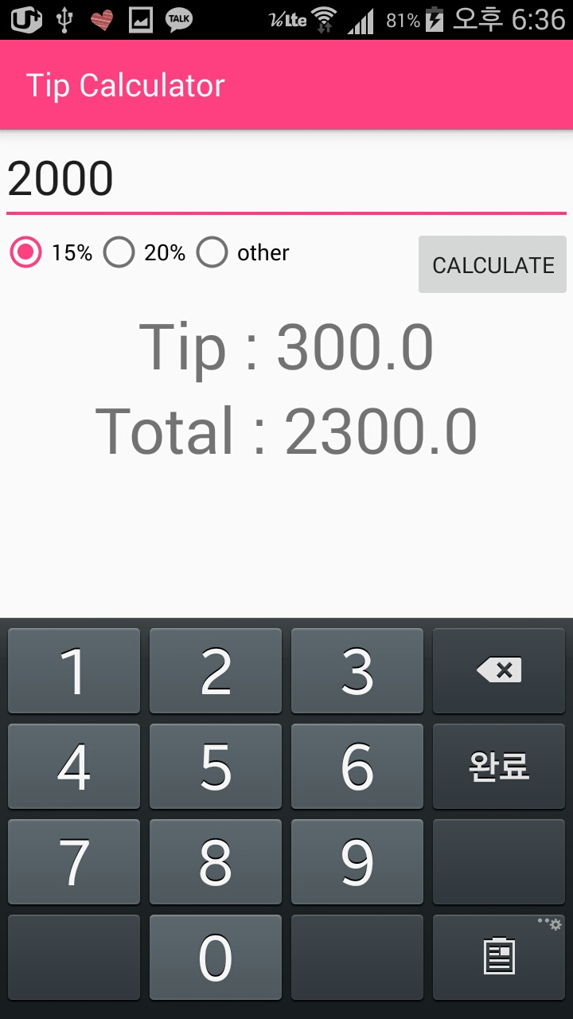 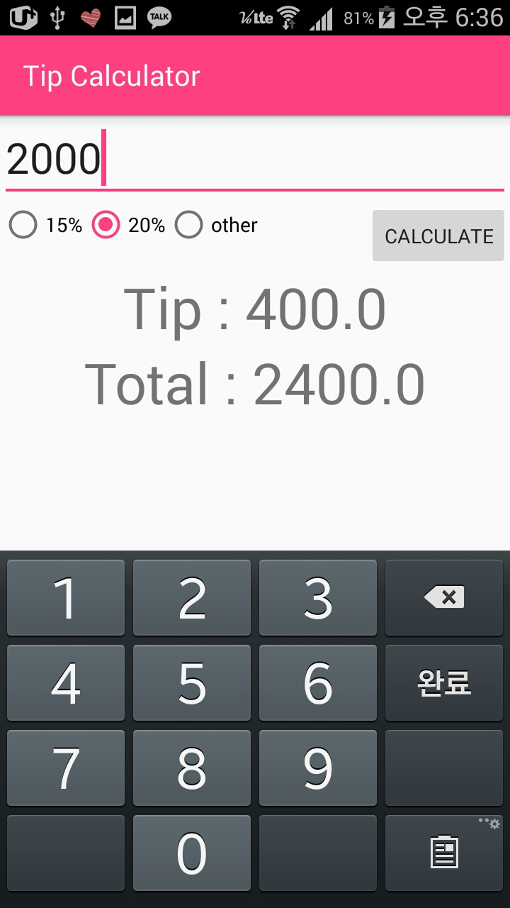

3. if there is no input values in Total Amount, 4. Show float point

Show messages.

+ if other button doesn’t clicked, EditText unvisiable

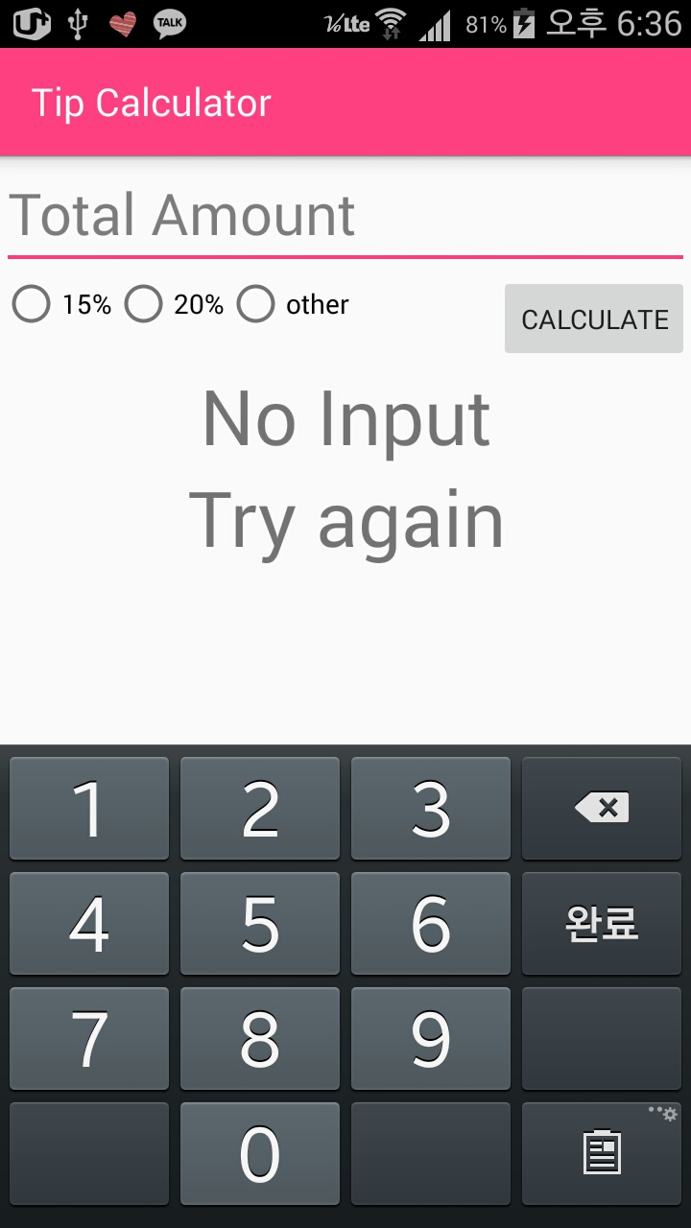 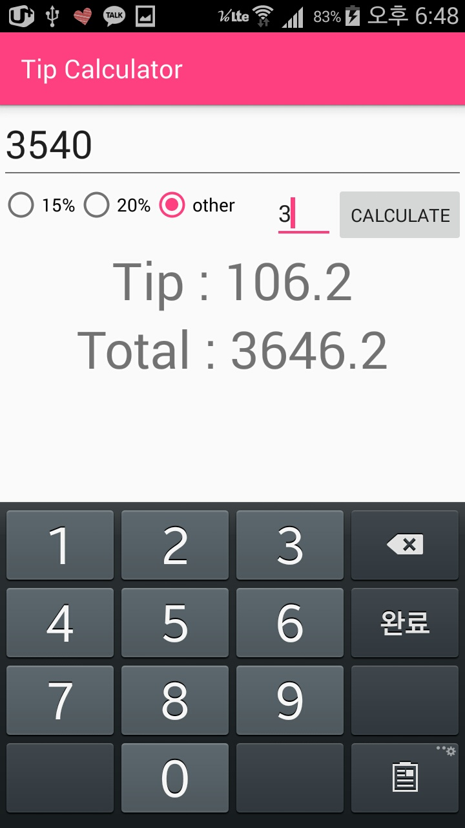

1. Calculate 2000 by 5% use other button. 6. If there is no input from other EditText, show

blanked message and calculate by 0%.

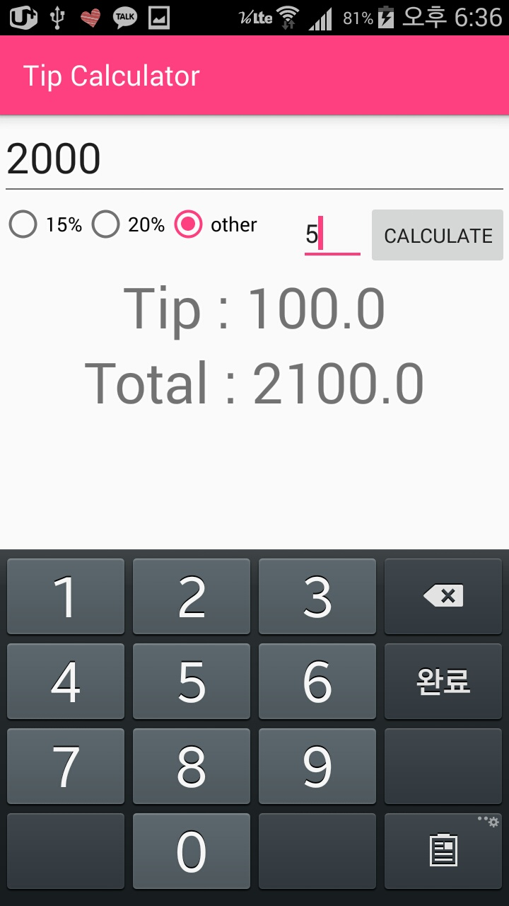 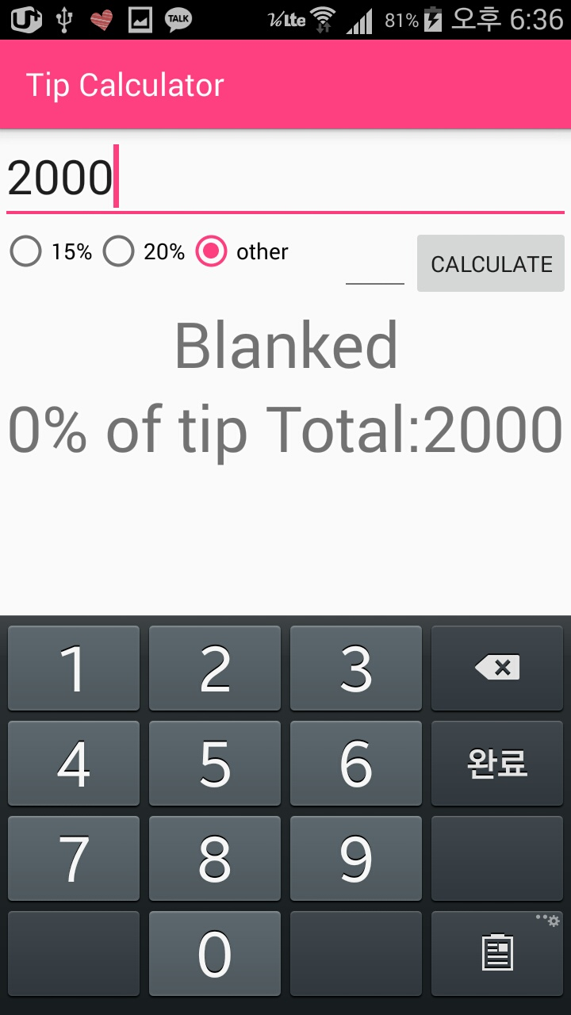

**HW1-B: Github**

<https://github.com/hansolkatarinekim/Mobile-Programming/tree/KatieKim-Lab1>

**HW1-B: MainActivity.java**

*//HW 1-B: Tip Calculator  
//2016-03-30  
//201333457 Hansol Kim  
//hansolkim0810@gmail.com***package** com.example.hansol.tipcalculator;  
  
**import** android.os.Bundle;  
**import** android.support.v7.app.AppCompatActivity;  
**import** android.view.View;  
**import** android.widget.Button;  
**import** android.widget.EditText;  
**import** android.widget.RadioButton;  
**import** android.widget.RadioGroup;  
**import** android.widget.TextView;  
  
**public class** MainActivity **extends** AppCompatActivity {  
 EditText **TypeTotalAmount**, **TypeOther**;  
 RadioGroup **RadioGroup**;  
 RadioButton **rad15**, **rad20**, **radOther**;  
 Button **btCalculate**;  
 TextView **ShowTip**, **ShowTotal**;  
 **float tip**;  
  
 @Override  
 **protected void** onCreate(Bundle savedInstanceState) {  
 **super**.onCreate(savedInstanceState);  
 setContentView(R.layout.***activity_main***);  
 **TypeTotalAmount** = (EditText) findViewById(R.id.***TypeTotalAmount***); **TypeOther** = (EditText) findViewById(R.id.***TypeOther***); **btCalculate** = (Button) findViewById(R.id.***btCalculate***);  
 **ShowTip** = (TextView) findViewById(R.id.***ShowTip***); **ShowTotal** = (TextView) findViewById(R.id.***ShowTotal***); **rad15** = (RadioButton) findViewById(R.id.***rad15***);  
 **rad20** = (RadioButton) findViewById(R.id.***rad20***);  
 **radOther** = (RadioButton) findViewById(R.id.***radOther***);  
  
 **btCalculate**.setOnClickListener(  
 **new** View.OnClickListener() {  
 @Override  
 **public void** onClick(View v) {  
 *//if there is no input, exception handling* **if** (**TypeTotalAmount**.getText().toString().equals(**""**)) {  
 **ShowTip**.setText(**"No Input"**);  
 **ShowTotal**.setText(**"Try again"**);  
 }  
 **else** {  
 *//if the RadOther checked, Edittext changes state to visible* **if** (**TypeOther**.getVisibility() == View.***VISIBLE***) {  
 *//if the Edittext of other is blanked input, exception handling* **if** (**TypeOther**.getText().toString().equals(**""**)) {  
 **ShowTip**.setText(**"Blanked"**);  
 **ShowTotal**.setText(**"0% of tip Total:"** + **TypeTotalAmount**.getText());  
 }  
 *//Calculate percentage of tip* **else** {  
 **tip** = Float.*parseFloat*(**TypeOther**.getText().toString());  
 **float** pay = Float.*parseFloat*(**TypeTotalAmount**.getText().toString());  
 **tip** = **tip** / 100;  
 **float** tip_money = pay * **tip**;  
 **ShowTip**.setText(**"Tip : "** + tip_money);  
 **ShowTotal**.setText(**"Total : "** + (tip_money + pay));  
 }  
 }  
 *//Calculate percentage of tip* **else** {  
 **float** pay = Float.*parseFloat*(**TypeTotalAmount**.getText().toString());  
 **float** tip_money = pay * **tip**;  
 **ShowTip**.setText(**"Tip : "** + tip_money);  
 **ShowTotal**.setText(**"Total : "** + (tip_money + pay));  
 }  
 }  
 }  
 }  
 );  
  
 **RadioGroup** = (RadioGroup) findViewById(R.id.***RadioGroup***);  
 **RadioGroup**.setOnCheckedChangeListener(  
 **new** RadioGroup.OnCheckedChangeListener() {  
 @Override  
 **public void** onCheckedChanged(RadioGroup group, **int** checkedId) {  
 *//if radio button of other checked, show EditText* **switch** (checkedId) {  
 **case** R.id.***rad15***:  
 **TypeOther**.setVisibility(View.***GONE***);  
 **tip** = (**float**) 0.15;  
 **break**;  
 **case** R.id.***rad20***:  
 **TypeOther**.setVisibility(View.***GONE***);  
 **tip** = (**float**) 0.2;  
 **break**;  
 **case** R.id.***radOther***:  
 **TypeOther**.setVisibility(View.***VISIBLE***);  
 **break**;  
 }  
 }  
 }  
 );  
 }  
  
 @Override  
 *//To save values for life cycle* **protected void** onSaveInstanceState(Bundle outState) {  
 **super**.onSaveInstanceState(outState);  
 outState.putString(**"TypeTotalAmount"**, (String) **TypeTotalAmount**.getText().toString());  
 outState.putString(**"TypeOther"**, (String) **TypeOther**.getText().toString());  
 outState.putString(**"ShowTip"**, (String) **ShowTip**.getText().toString());  
 outState.putString(**"ShowTotal"**, (String) **ShowTotal**.getText().toString());  
 outState.putInt(**"check"**, **RadioGroup**.getCheckedRadioButtonId());  
 }  
  
 @Override  
 *//To call saved values for life cycle* **protected void** onRestoreInstanceState(Bundle savedInstanceState) {  
 **super**.onRestoreInstanceState(savedInstanceState);  
 **TypeTotalAmount**.setText(savedInstanceState.getString(**"TypeTotalAmount"**));  
 **TypeOther**.setText(savedInstanceState.getString(**"TypeOther"**));  
 **ShowTip**.setText(savedInstanceState.getString(**"ShowTip"**));  
 **ShowTotal**.setText(savedInstanceState.getString(**"ShowTotal"**));  
  
 **if** (R.id.***rad15*** == savedInstanceState.getInt(**"check"**))  
 **rad15**.setChecked(**true**);  
 **else if** (R.id.***rad20*** == savedInstanceState.getInt(**"check"**))  
 **rad20**.setChecked(**true**);  
 **else if** (R.id.***radOther*** == savedInstanceState.getInt(**"check"**))  
 **radOther**.setChecked(**true**);  
 }  
}

**HW1-B: activity_main.xml**

*<?***xml version="1.0" encoding="utf-8"***?>*<**LinearLayout xmlns:android="http://schemas.android.com/apk/res/android"  
 xmlns:tools="http://schemas.android.com/tools"  
 android:layout_width="match_parent"  
 android:layout_height="match_parent"  
 android:orientation="vertical"**>  
  
 <**EditText  
 android:id="@+id/TypeTotalAmount"  
 android:layout_width="match_parent"  
 android:layout_height="wrap_content"  
 android:hint="Total Amount"  
 android:inputType="number"  
 android:maxLength="7"  
 android:text=""  
 android:textSize="30dp"** />  
  
 <**LinearLayout  
 android:layout_width="match_parent"  
 android:layout_height="wrap_content"**>  
  
 <**RadioGroup  
 android:id="@+id/RadioGroup"  
 android:layout_width="wrap_content"  
 android:layout_height="wrap_content"  
 android:layout_weight="0.3"  
 android:orientation="horizontal"**>  
  
 <**RadioButton  
 android:id="@+id/rad15"  
 android:layout_width="wrap_content"  
 android:layout_height="wrap_content"  
 android:text="15%"** />  
  
 <**RadioButton  
 android:id="@+id/rad20"  
 android:layout_width="wrap_content"  
 android:layout_height="wrap_content"  
 android:text="20%"** />  
  
 <**RadioButton  
 android:id="@+id/radOther"  
 android:layout_width="wrap_content"  
 android:layout_height="wrap_content"  
 android:text="other"** />  
 </**RadioGroup**>  
  
 <**EditText  
 android:id="@+id/TypeOther"  
 android:layout_width="wrap_content"  
 android:layout_height="wrap_content"  
 android:layout_weight="0.3"  
 android:inputType="number"  
 android:maxLength="3"  
 android:text=""  
 android:visibility="invisible"** />  
  
 <**Button  
 android:id="@+id/btCalculate"  
 android:layout_width="wrap_content"  
 android:layout_height="wrap_content"  
 android:text="calculate"** />  
 </**LinearLayout**>  
  
 <**TextView  
 android:id="@+id/ShowTip"  
 android:layout_width="match_parent"  
 android:layout_height="wrap_content"  
 android:text=""  
 android:textAlignment="center"  
 android:textSize="40dp"** />  
  
 <**TextView  
 android:id="@+id/ShowTotal"  
 android:layout_width="match_parent"  
 android:layout_height="wrap_content"  
 android:text=""  
 android:textAlignment="center"  
 android:textSize="40dp"** />  
</**LinearLayout**>

**HW1-C: Screenshot**

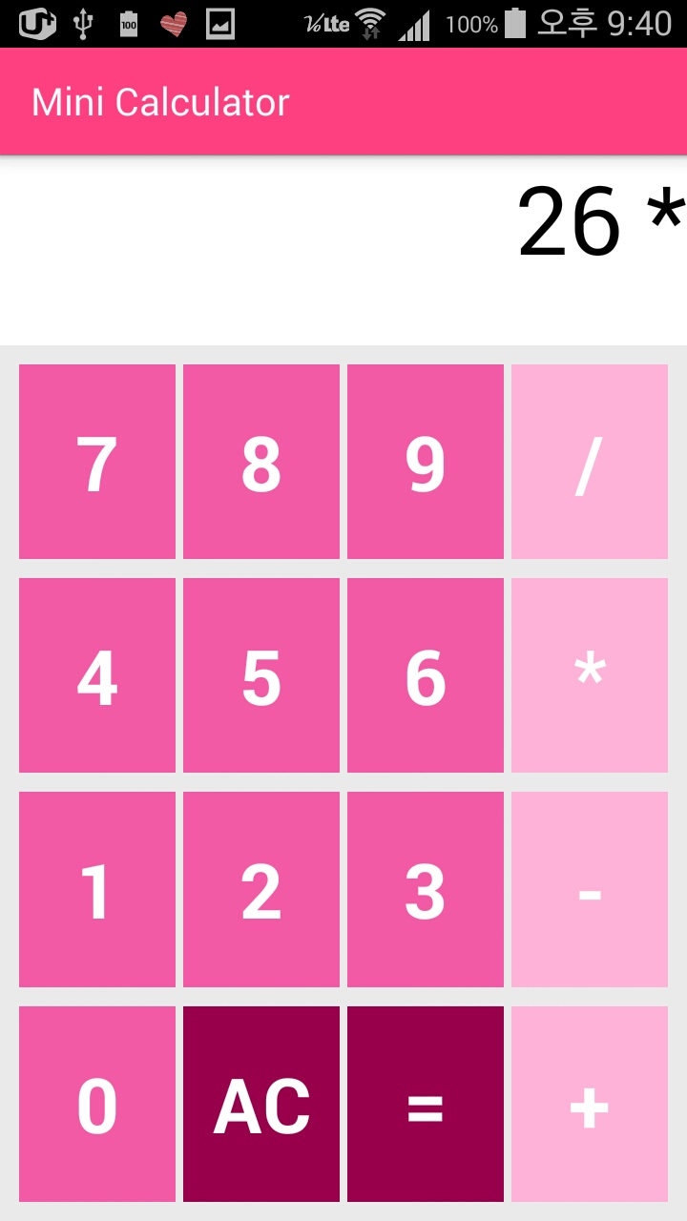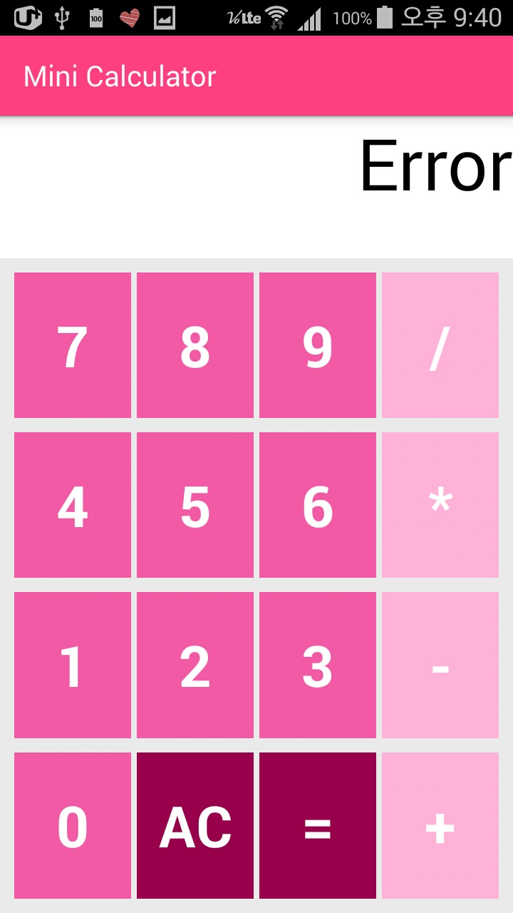

1. **Show message after type Equal button, after type symbols**

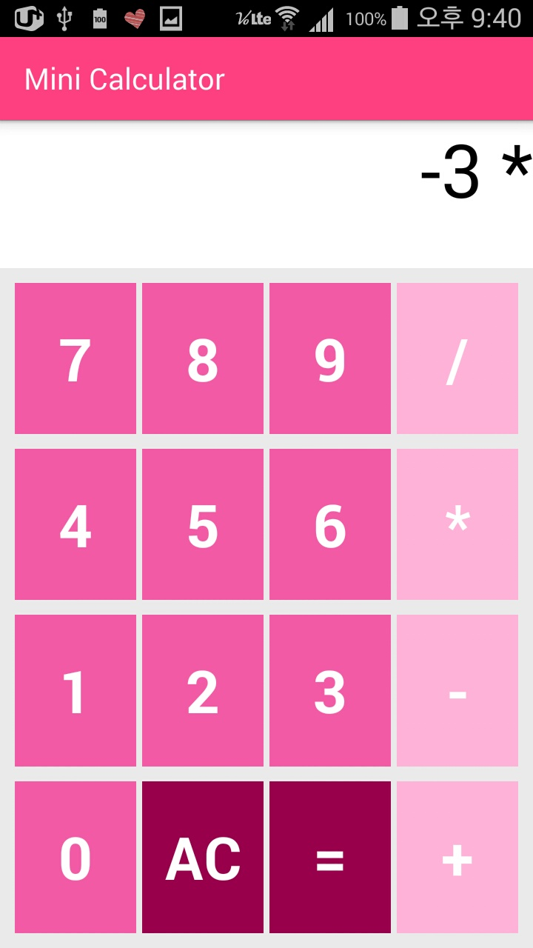 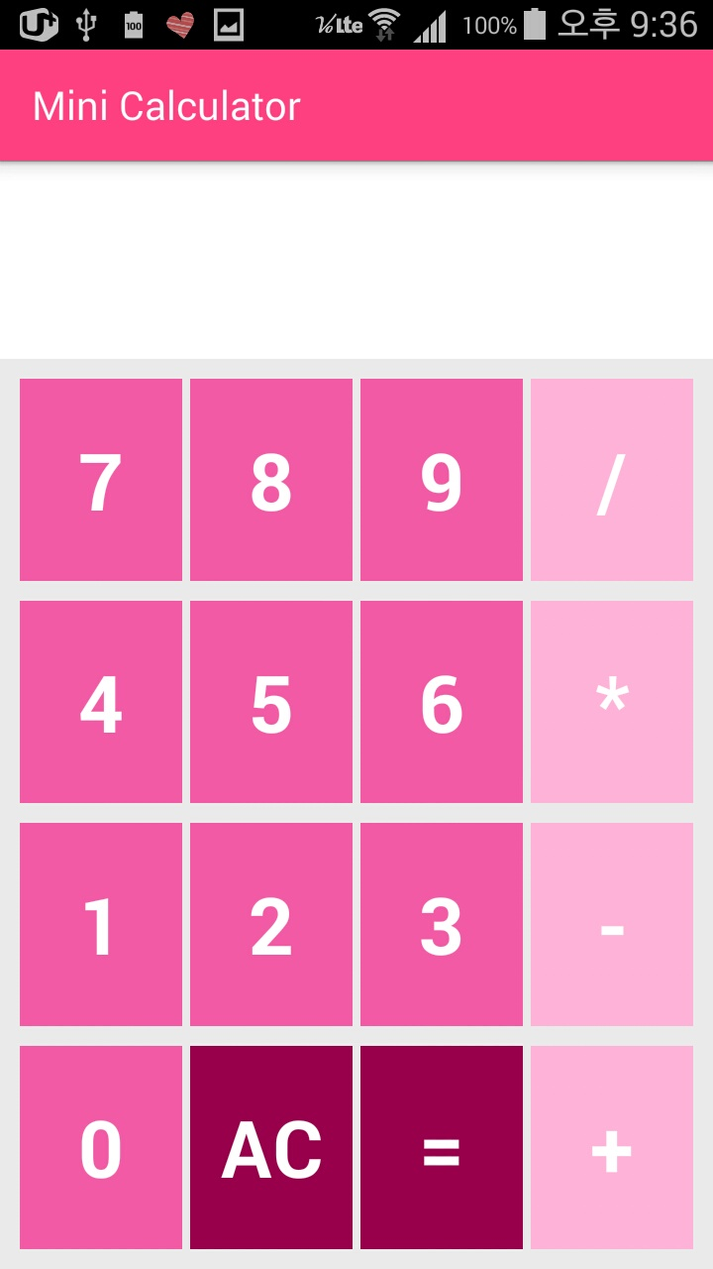

1. **Exception handling minus symbol can type in front of input number**

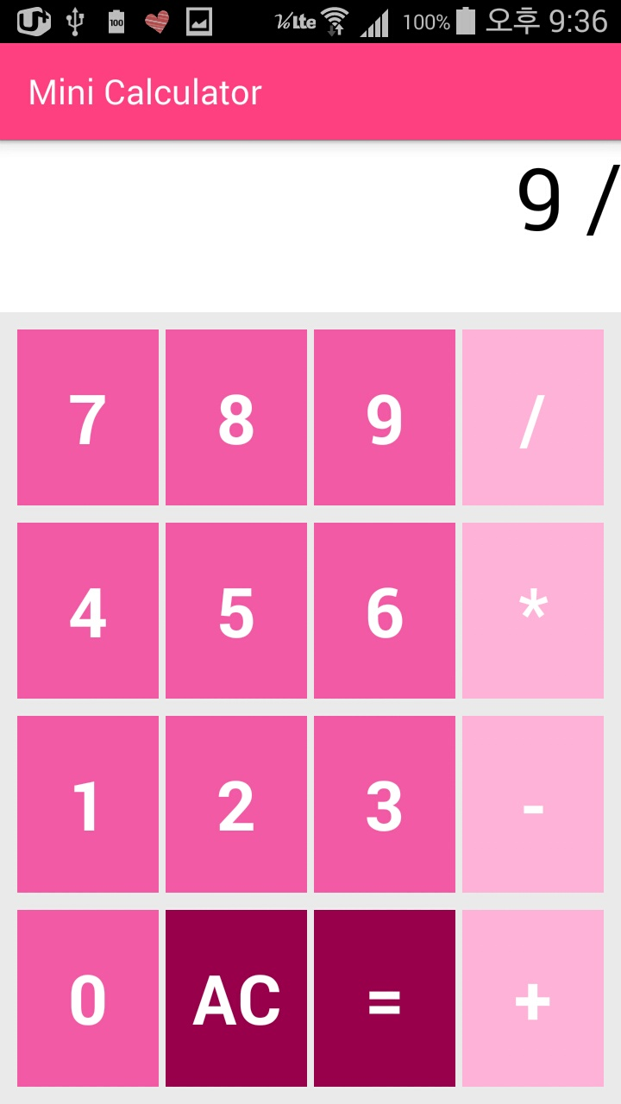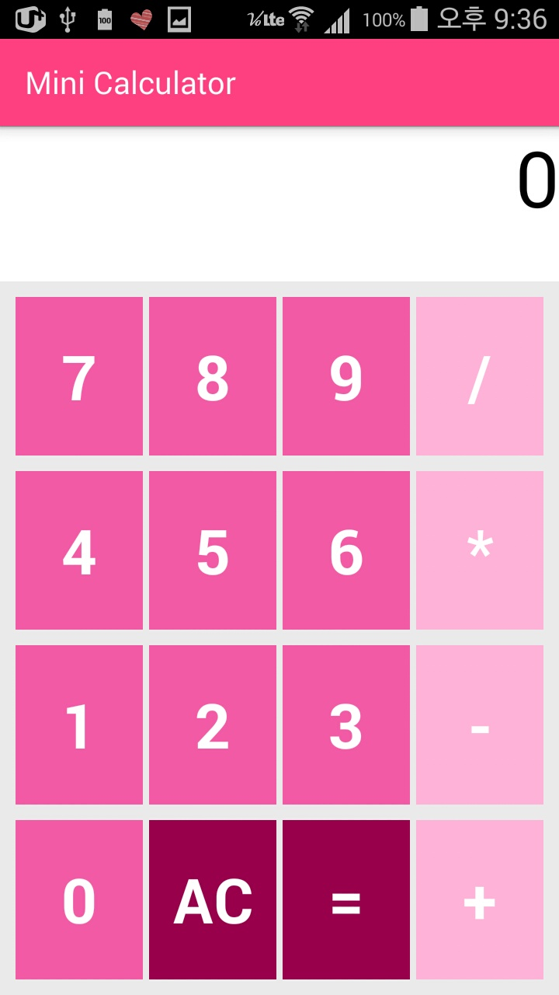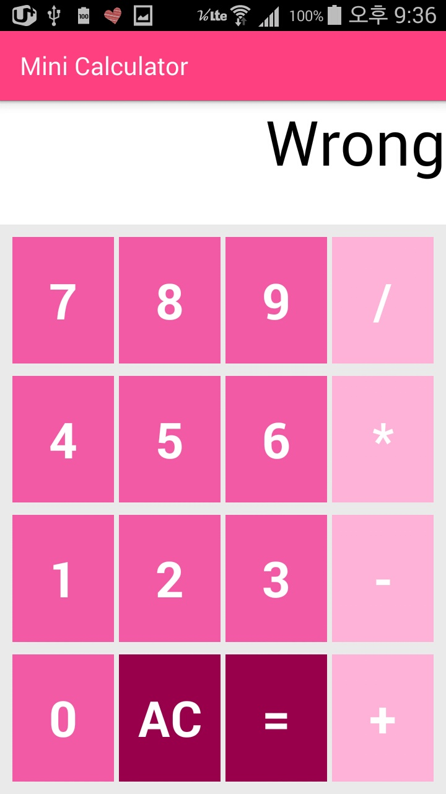

1. **if divide with 0, show message**

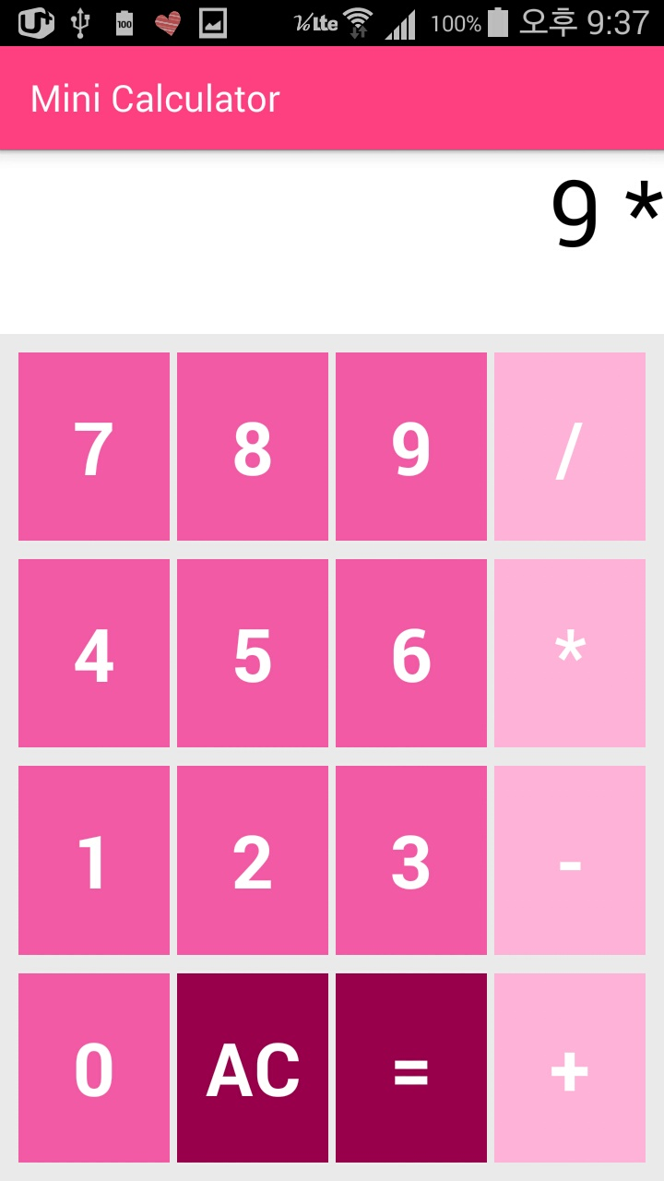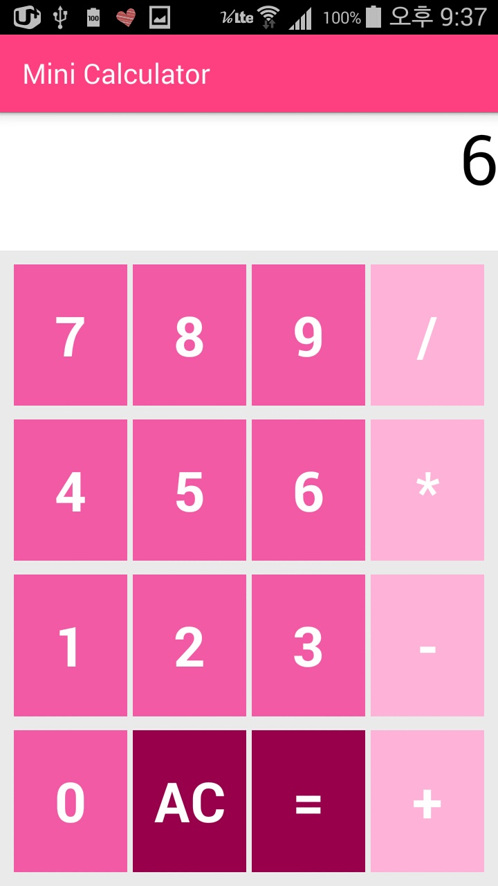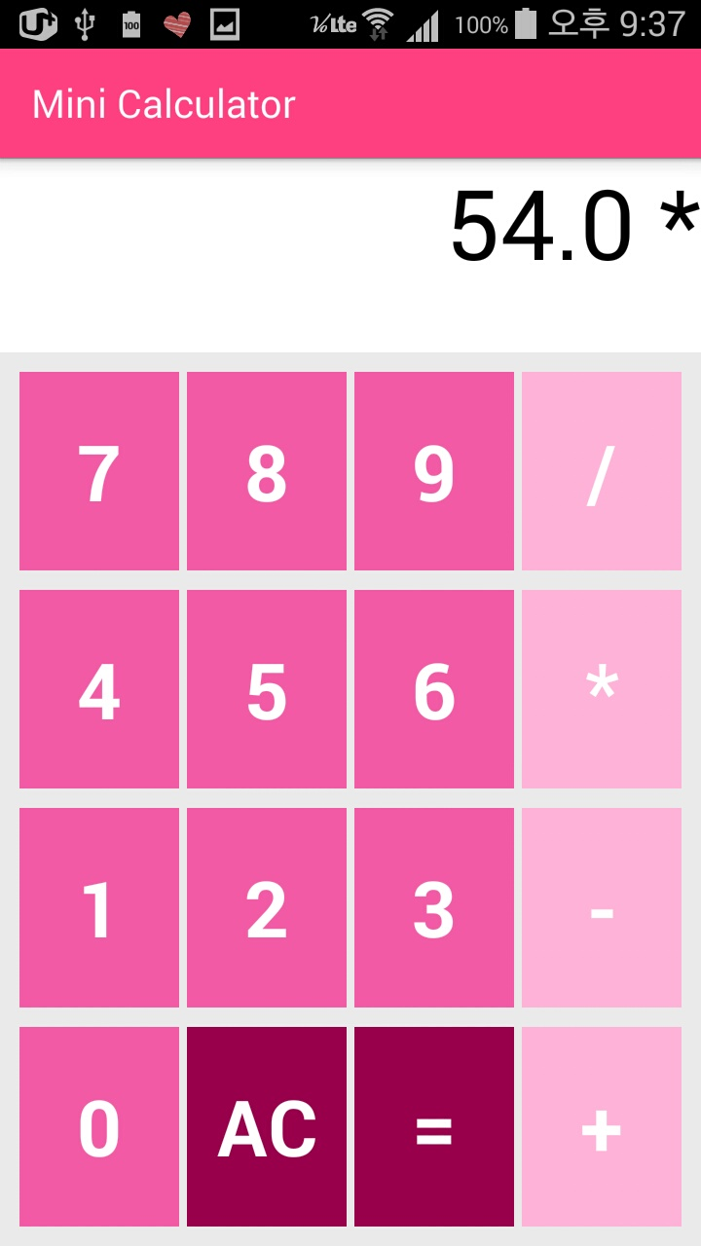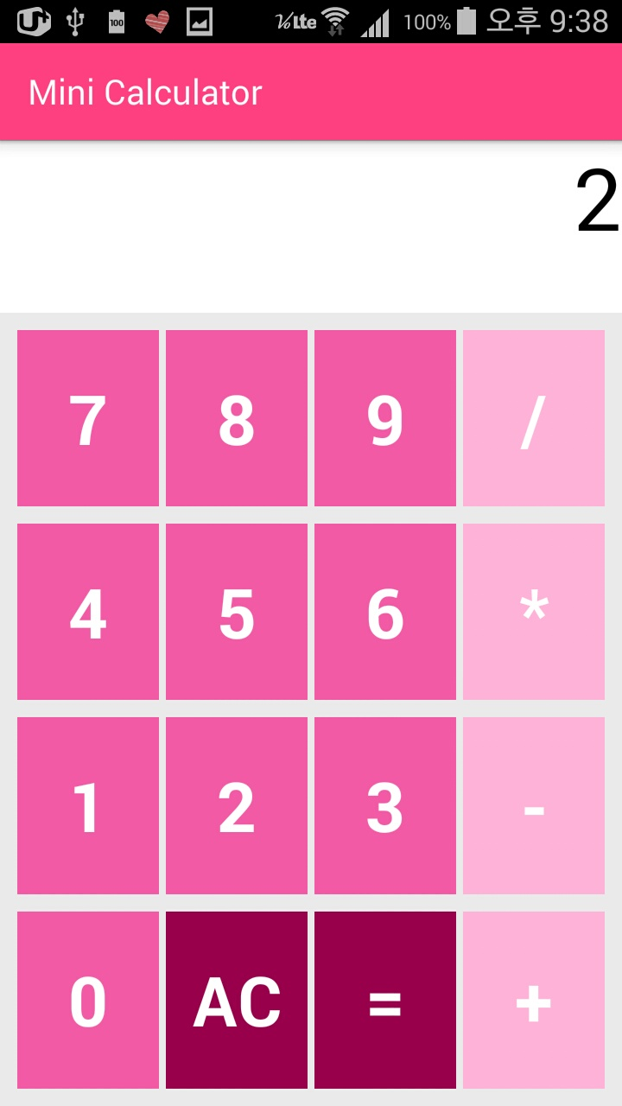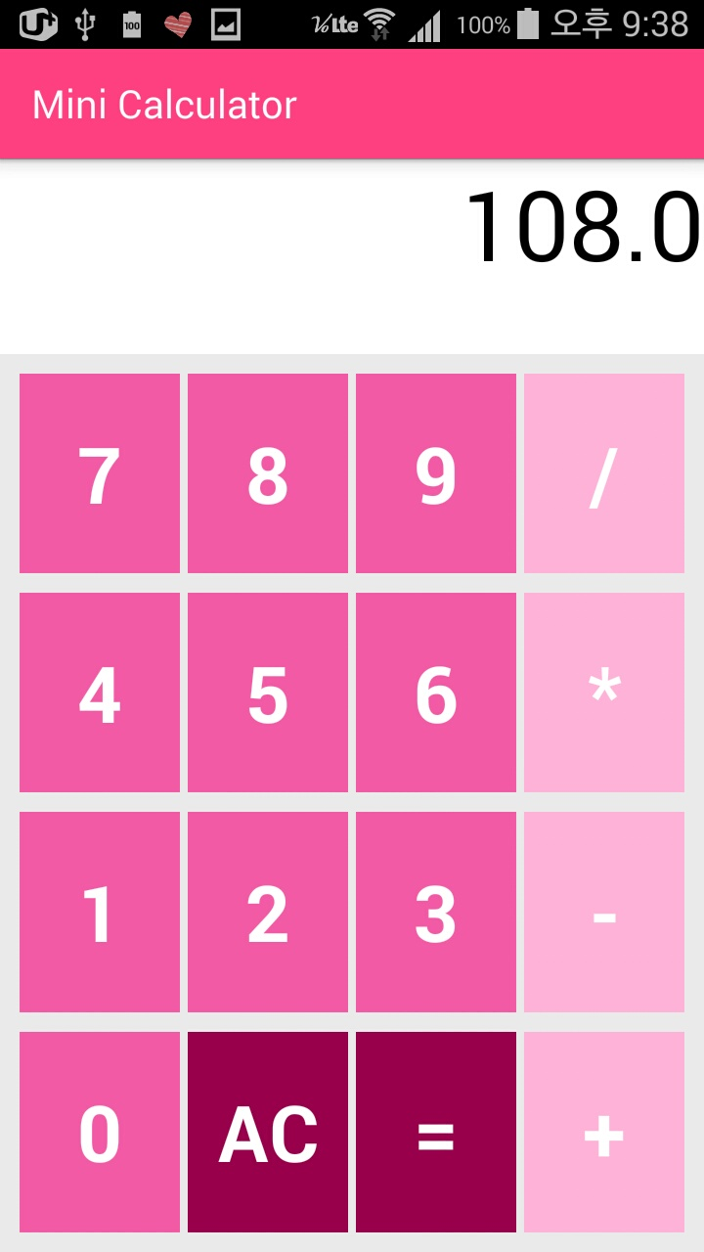

1. **if type equation straightly ‘9*6=’ (X) -> ‘9*6*2=’. This case acceptable.**

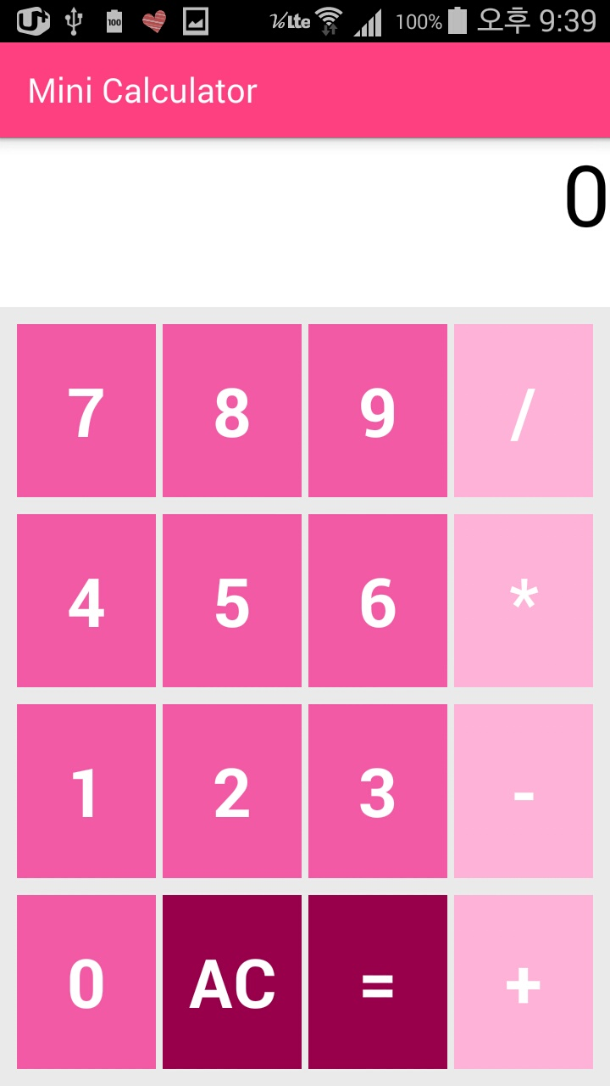

1. **Cannot put 0 more than one.**

**HW1-C: Github**

<https://github.com/hansolkatarinekim/Mobile-Programming/tree/KatieKim-Lab1>

**HW1-C: MainActivity.java**

*//HW 1-C: Mini Calculator  
//2016-03-31  
//201333457 Hansol Kim  
//hansolkim0810@gmail.com***package** com.example.hansol.minicalculator;  
  
**import** android.os.Bundle;  
**import** android.support.v7.app.AppCompatActivity;  
**import** android.view.View;  
**import** android.widget.Button;  
**import** android.widget.TextView;  
  
**public class** MainActivity **extends** AppCompatActivity **implements** View.OnClickListener {  
 TextView **tvTypeNumber**;  
 **boolean repeatSymbol** = **false**;  
 **boolean input2** = **false**;  
 String **str** = **""**;  
 String **a** = **""**;  
 **float result** = 0;  
 Button **bt1**, **bt2**, **bt3**, **bt4**, **bt5**, **bt6**, **bt7**, **bt8**, **bt9**, **bt0**, **btAC**, **btEqual**, **btMul**, **btPlu**, **btMin**, **btDiv**;  
  
 @Override  
 **protected void** onCreate(Bundle savedInstanceState) {  
 **super**.onCreate(savedInstanceState);  
 setContentView(R.layout.***activity_main***);  
  
 **tvTypeNumber** = (TextView) findViewById(R.id.***tvTypeNumber***);  
 **bt1** = (Button) findViewById(R.id.***bt1***);  
 **bt2** = (Button) findViewById(R.id.***bt2***);  
 **bt3** = (Button) findViewById(R.id.***bt3***);  
 **bt4** = (Button) findViewById(R.id.***bt4***);  
 **bt5** = (Button) findViewById(R.id.***bt5***);  
 **bt6** = (Button) findViewById(R.id.***bt6***);  
 **bt7** = (Button) findViewById(R.id.***bt7***);  
 **bt8** = (Button) findViewById(R.id.***bt8***);  
 **bt9** = (Button) findViewById(R.id.***bt9***);  
 **bt0** = (Button) findViewById(R.id.***bt0***);  
 **btAC** = (Button) findViewById(R.id.***btAC***);  
 **btEqual** = (Button) findViewById(R.id.***btEqual***);  
 **btPlu** = (Button) findViewById(R.id.***btPlu***);  
 **btMul** = (Button) findViewById(R.id.***btMul***);  
 **btDiv** = (Button) findViewById(R.id.***btDiv***);  
 **btMin** = (Button) findViewById(R.id.***btMin***);  
  
 **bt1**.setOnClickListener(**this**);  
 **bt2**.setOnClickListener(**this**);  
 **bt3**.setOnClickListener(**this**);  
 **bt4**.setOnClickListener(**this**);  
 **bt5**.setOnClickListener(**this**);  
 **bt6**.setOnClickListener(**this**);  
 **bt7**.setOnClickListener(**this**);  
 **bt8**.setOnClickListener(**this**);  
 **bt9**.setOnClickListener(**this**);  
 **bt0**.setOnClickListener(**this**);  
 **btEqual**.setOnClickListener(**this**);  
 **btAC**.setOnClickListener(**this**);  
 **btPlu**.setOnClickListener(**this**);  
 **btMin**.setOnClickListener(**this**);  
 **btMul**.setOnClickListener(**this**);  
 **btDiv**.setOnClickListener(**this**);  
 }  
  
 @Override  
 **public void** onClick(View v) {  
 *//if click AC button, reset it* **if** (v.getId() == R.id.***btAC***) {  
 **str** = **""**;  
 **repeatSymbol** = **false**;  
 **tvTypeNumber**.setText(**""**);  
 **input2** = **false**;  
 **result** = 0;  
 }  
 **else if** (v.getId() == R.id.***btEqual***) {  
 **if** (**str**.equals(**""**) && **input2** == **false** && **repeatSymbol** == **false**)  
 **tvTypeNumber**.setText(**""** + **result**);  
 *//after click '=' button works* **else if** (**str**.equals(**""**) && **input2** == **true** && **repeatSymbol** == **false**)  
 **tvTypeNumber**.setText(**"Error"**);  
 *//only number accepted* **else if** (**input2** == **false** == **repeatSymbol** == **true**)  
 **tvTypeNumber**.setText(**""** + **result**);  
 **else** {  
 **if** (**a**.equals(**"-"**)) {  
 **result** -= Float.*parseFloat*(**str**);  
 **tvTypeNumber**.setText(**""** + **result**);  
 **str** = **""** + **result**;  
 }  
 **else if** (**a**.equals(**"+"**)) {  
 **result** += Float.*parseFloat*(**str**);  
 **tvTypeNumber**.setText(**""** + **result**);  
 **str** = **""** + **result**;  
 }  
 **else if** (**a**.equals(**"*"**)) {  
 **result** *= Float.*parseFloat*(**str**);  
 **tvTypeNumber**.setText(**""** + **result**);  
 **str** = **""** + **result**;  
 }  
 **else** {  
 *//if divide 0, show message* **if** (**str**.equals(**"0"**)) {  
 **tvTypeNumber**.setText(**"Wrong"**);  
 **str** = **""**;  
 **repeatSymbol** = **false**;  
 **input2** = **false**;  
 **result** = 0;  
 }  
 **else** {  
 **result** /= Float.*parseFloat*(**str**);  
 **tvTypeNumber**.setText(**""** + **result**);  
 **str** = **""** + **result**;  
 }  
 }  
 **input2** = **false**;  
 }  
 }  
 **else if** (v.getId() == R.id.***btMul*** || v.getId() == R.id.***btPlu*** || v.getId() == R.id.***btDiv*** || v.getId() == R.id.***btMin***) {  
 Button b = (Button) v;  
 *//make sure that only the first '-' is accepted* **if** (**str**.equals(**""**) && ((Button) v).getText().equals(**"-"**)) {  
 **str** = ((Button) v).getText().toString();  
 }  
 *//exception handling of a+b+c = (a+b)+c* **if** (**repeatSymbol** == **true** && **input2** == **false**) {  
 **result** = Float.*parseFloat*(**str**);  
 **a** = ((Button) v).getText().toString();  
 **tvTypeNumber**.setText(**str** + **" "** + **a**);  
 **str** = **""**;  
 **repeatSymbol** = **false**;  
 **input2** = **true**;  
 }  
 **else if** (**repeatSymbol** == **true** && **input2** == **true**) {  
 **if** (**a**.equals(**"-"**))  
 **result** -= Float.*parseFloat*(**str**);  
 **else if** (**a**.equals(**"+"**))  
 **result** += Float.*parseFloat*(**str**);  
  
 **else if** (**a**.equals(**"*"**))  
 **result** *= Float.*parseFloat*(**str**);  
 **else** {  
 **if** (**str**.equals(**"0"**)) {  
 **tvTypeNumber**.setText(**"Wrong"**);  
 **str** = **""**;  
 **repeatSymbol** = **false**;  
 **input2** = **false**;  
 **result** = 0;  
 }  
 **else  
 result** /= Float.*parseFloat*(**str**);  
 }  
 **a** = ((Button) v).getText().toString();  
 **tvTypeNumber**.setText(**""** + **result** + **" "** + **a**);  
 **str** = **""**;  
 **repeatSymbol** = **false**;  
 }  
 }  
 **else** {  
 Button b = (Button) v;  
 *//exception handling of use only one 0 for first input* **if** (**str**.equals(**"0"**) && b.getText().equals(**"0"**)) {  
  
 }  
 **else** {  
 **if** (**str**.equals(**"0"**))  
 **str** = b.getText().toString();  
 **else  
 str** += b.getText().toString();  
 **tvTypeNumber**.setText(**str**);  
 **repeatSymbol** = **true**;  
 }  
 }  
 }  
}

**HW1-C: activity_main.xml**

*<?***xml version="1.0" encoding="utf-8"***?>*<**RelativeLayout xmlns:android="http://schemas.android.com/apk/res/android"  
 xmlns:tools="http://schemas.android.com/tools"  
 android:layout_width="match_parent"  
 android:layout_height="match_parent"  
 android:background="#EAEAEA"**>  
  
 <**TextView  
 android:id="@+id/tvTypeNumber"  
 android:layout_width="match_parent"  
 android:layout_height="100dp"  
 android:layout_alignParentLeft="true"  
 android:layout_alignParentStart="true"  
 android:layout_alignParentTop="true"  
 android:layout_weight="0.5"  
 android:background="#FFFFFF"  
 android:gravity="right"  
 android:maxLength="7"  
 android:text=""  
 android:textColor="#000000"  
 android:textSize="50dp"** />  
  
 <**TableLayout  
 android:layout_width="match_parent"  
 android:layout_height="wrap_content"  
 android:layout_alignParentBottom="true"  
 android:layout_alignParentLeft="true"  
 android:layout_alignParentRight="true"  
 android:layout_below="@+id/tvTypeNumber"  
 android:padding="5dp"**>  
  
 <**TableRow  
 android:layout_margin="3dp"  
 android:layout_weight="1"**>  
  
 <**Button  
 android:id="@+id/bt7"  
 android:layout_height="match_parent"  
 android:layout_margin="2dp"  
 android:layout_weight="1"  
 android:background="#F35AA6"  
 android:onClick="saveNumber"  
 android:text="7"  
 android:textColor="#FFFFFF"  
 android:textSize="40dp"  
 android:textStyle="bold"** />  
  
 <**Button  
 android:id="@+id/bt8"  
 android:layout_height="match_parent"  
 android:layout_margin="2dp"  
 android:layout_weight="1"  
 android:background="#F35AA6"  
 android:onClick="saveNumber"  
 android:text="8"  
 android:textColor="#FFFFFF"  
 android:textSize="40dp"  
 android:textStyle="bold"** />  
  
 <**Button  
 android:id="@+id/bt9"  
 android:layout_height="match_parent"  
 android:layout_margin="2dp"  
 android:layout_weight="1"  
 android:background="#F35AA6"  
 android:onClick="saveNumber"  
 android:text="9"  
 android:textColor="#FFFFFF"  
 android:textSize="40dp"  
 android:textStyle="bold"** />  
  
 <**Button  
 android:id="@+id/btDiv"  
 android:layout_height="match_parent"  
 android:layout_margin="2dp"  
 android:layout_weight="1"  
 android:background="#FFB2D9"  
 android:onClick="saveinput"  
 android:text="/"  
 android:textColor="#FFFFFF"  
 android:textSize="40dp"  
 android:textStyle="bold"** />  
 </**TableRow**>  
  
 <**TableRow  
 android:layout_margin="3dp"  
 android:layout_weight="1"**>  
  
 <**Button  
 android:id="@+id/bt4"  
 android:layout_height="match_parent"  
 android:layout_margin="2dp"  
 android:layout_weight="1"  
 android:background="#F35AA6"  
 android:onClick="saveNumber"  
 android:text="4"  
 android:textColor="#FFFFFF"  
 android:textSize="40dp"  
 android:textStyle="bold"** />  
  
 <**Button  
 android:id="@+id/bt5"  
 android:layout_height="match_parent"  
 android:layout_margin="2dp"  
 android:layout_weight="1"  
 android:background="#F35AA6"  
 android:onClick="saveNumber"  
 android:text="5"  
 android:textColor="#FFFFFF"  
 android:textSize="40dp"  
 android:textStyle="bold"** />  
  
 <**Button  
 android:id="@+id/bt6"  
 android:layout_height="match_parent"  
 android:layout_margin="2dp"  
 android:layout_weight="1"  
 android:background="#F35AA6"  
 android:onClick="saveNumber"  
 android:text="6"  
 android:textColor="#FFFFFF"  
 android:textSize="40dp"  
 android:textStyle="bold"** />  
  
 <**Button  
 android:id="@+id/btMul"  
 android:layout_height="match_parent"  
 android:layout_margin="2dp"  
 android:layout_weight="1"  
 android:background="#FFB2D9"  
 android:onClick="saveinput"  
 android:text="*"  
 android:textColor="#FFFFFF"  
 android:textSize="40dp"  
 android:textStyle="bold"** />  
 </**TableRow**>  
  
 <**TableRow  
 android:layout_margin="3dp"  
 android:layout_weight="1"**>  
  
 <**Button  
 android:id="@+id/bt1"  
 android:layout_height="match_parent"  
 android:layout_margin="2dp"  
 android:layout_weight="1"  
 android:background="#F35AA6"  
 android:onClick="saveNumber"  
 android:text="1"  
 android:textColor="#FFFFFF"  
 android:textSize="40dp"  
 android:textStyle="bold"** />  
  
 <**Button  
 android:id="@+id/bt2"  
 android:layout_height="match_parent"  
 android:layout_margin="2dp"  
 android:layout_weight="1"  
 android:background="#F35AA6"  
 android:onClick="saveNumber"  
 android:text="2"  
 android:textColor="#FFFFFF"  
 android:textSize="40dp"  
 android:textStyle="bold"** />  
  
 <**Button  
 android:id="@+id/bt3"  
 android:layout_height="match_parent"  
 android:layout_margin="2dp"  
 android:layout_weight="1"  
 android:background="#F35AA6"  
 android:onClick="saveNumber"  
 android:text="3"  
 android:textColor="#FFFFFF"  
 android:textSize="40dp"  
 android:textStyle="bold"** />  
  
 <**Button  
 android:id="@+id/btMin"  
 android:layout_height="match_parent"  
 android:layout_margin="2dp"  
 android:layout_weight="1"  
 android:background="#FFB2D9"  
 android:onClick="saveinput"  
 android:text="-"  
 android:textColor="#FFFFFF"  
 android:textSize="40dp"  
 android:textStyle="bold"** />  
 </**TableRow**>  
  
 <**TableRow  
 android:layout_margin="3dp"  
 android:layout_weight="1"**>  
  
 <**Button  
 android:id="@+id/bt0"  
 android:layout_height="match_parent"  
 android:layout_margin="2dp"  
 android:layout_weight="1"  
 android:background="#F35AA6"  
 android:onClick="saveNumber"  
 android:text="0"  
 android:textColor="#FFFFFF"  
 android:textSize="40dp"  
 android:textStyle="bold"** />  
  
 <**Button  
 android:id="@+id/btAC"  
 android:layout_height="match_parent"  
 android:layout_margin="2dp"  
 android:layout_weight="1"  
 android:background="#99004C"  
 android:onClick="cleanfield1"  
 android:text="AC"  
 android:textColor="#FFFFFF"  
 android:textSize="40dp"  
 android:textStyle="bold"** />  
  
 <**Button  
 android:id="@+id/btEqual"  
 android:layout_height="match_parent"  
 android:layout_margin="2dp"  
 android:layout_weight="1"  
 android:background="#99004C"  
 android:onClick="resultnum"  
 android:text="="  
 android:textColor="#FFFFFF"  
 android:textSize="40dp"  
 android:textStyle="bold"** />  
  
 <**Button  
 android:id="@+id/btPlu"  
 android:layout_height="match_parent"  
 android:layout_margin="2dp"  
 android:layout_weight="1"  
 android:background="#FFB2D9"  
 android:onClick="saveinput"  
 android:text="+"  
 android:textColor="#FFFFFF"  
 android:textSize="40dp"  
 android:textStyle="bold"** />  
 </**TableRow**>  
 </**TableLayout**>  
</**RelativeLayout**>